Q: Are all of these enough to get full marks in the exam?

A: NO. This is a practice sheet. Meaning, you can practice all you want using the questions from this sheet. However, doing well in exams depends upon your ability to understand a question, formulate an answer, and express it correctly. You see, these are humane skills that cannot be guaranteed by completing a practice sheet only. But yeah, Best of luck anyway.

Chapter 1 (Computer Abstractions and Technology)

Question - 1:
Assume a 19 cm diameter wafer, X has a cost of 20, contains 89 dies, and has 0.023 defects/cm². Assume another 20 cm diameter wafer, Y has a cost of 15, contains 100 dies, and has 0.031 defects/cm². Consider N = 2.
- What do you understand by yield?
- Dies per wafer ≈ Wafer area / Die Area - Explain why there is “≈” not “=”
- Find the yield for both wafers.
- Find the cost per die for both wafers.

Question - 2:
Suppose gaming consoles PlayStation 5 and Xbox Series X use different implementations of AMD's Zen 2 architecture. The instructions they support can be divided into four classes according to their CPI (class A, B, C, and D). PlayStation has a clock rate of 2.7 GHz and the instruction classes have CPIs of 7, 2, 3, and 6 respectively whereas Xbox has a clock rate of 3.0 GHz and the instruction classes have CPIs of 5, 4, 2, and 1 respectively. Now suppose, a program has an instruction count of 1.0 ∗ 10^6, and the instructions are
divided into classes as follows:
30% class A,
50% class B,
10% class C, and
10% class D.
Now answer the following questions:
1. Calculate how many more clock cycles per instruction on average does the
PlayStation take compared to the Xbox?
2. Calculate the difference between the execution time in these two consoles in
milliseconds
3. If the program runs on a reference PC with an execution time of 120 ms, calculate the SPECRatio for the PlayStation

Question - 3:
Consider three different processors P1, P2, and P3 executing the exact same instruction set. P1 has a 3 GHz clock rate and a CPI of 1.5. P2 has a 2.5 GHz clock rate and a CPI of 1.0. P3 has a 4.0 GHz clock rate and has a CPI of 2.2.
Now answer the following questions:
- Which processor has the highest performance expressed in instructions per second?
- If the processors each execute a program in 10 seconds, find the number of cycles and the number of instructions.
- We are trying to reduce the execution time by 30%, but this leads to an increase of 20% in the CPI. What clock rate should we have to get this time reduction?

Question - 4:
Consider a computer running a program that requires 250s, with 70s spent executing add instructions, 85s executed sub instructions, and 40s spent executing left-shift instructions.
- By how much is the total time reduced if the time for add operations is reduced by 20%?
- Can the total time can be reduced by 20% by reducing only the time for left-shift instructions?

Question - 5:
Processor, P1 has a clock rate of 4 GHz, average CPI of 0.9, and requires the execution of 5.0E9 instructions. Processor,P2 has a clock rate of 3 GHz, an average CPI of 0.75, and requires the execution of 1.0E9 instructions.

- We consider the processor with the largest MIPS has the largest performance. See if this is true for Processor P1 and P2.

Question - 6:
Explain the power trend equation. If a new system has 14.3% less capacitive
load and uses only 81.3% of the voltage and frequency of the old system, what
percentage of power utilization can be reduced in the new system compared to
the old system?

Question - 7
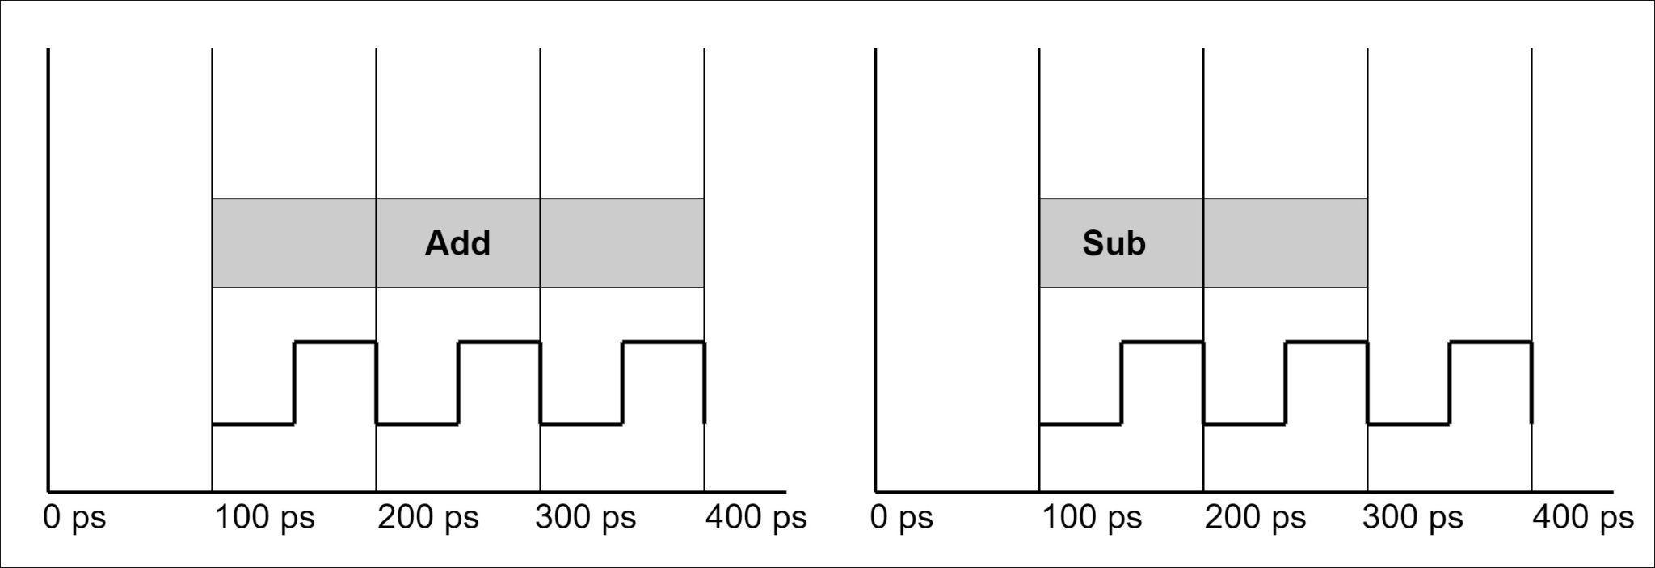
Figure 1: Represents 1 add instruction Figure 2: Represents 1 sub instruction

Program A is divided into two classes according to their CPI (Add and Sub). The instruction counts are 21 and 3 respectively. Reference for program A is 1080ps.
Now, answer the following questions,
- What is the Clock period? Hint: follow any of the figures
- What is the frequency?
- What is the CPI for Add and Sub ?
- What is the Avg. CPI?
- Find out the execution time of the program?
- Find the SPEC ratio?
- If you want to improve the performance by 1.2 times, what improvement do you need to include in the program’s add operation?

